Week 4
- Write a java program to check whether the given number is odd or even.
Program:
package week4;
public class evenodd {
public static void main(String args[]) {
int num=14;
if(num%2==0){
System.out.println("Even.");
}
else{
System.out.println("Odd");
}
}
}
Output:
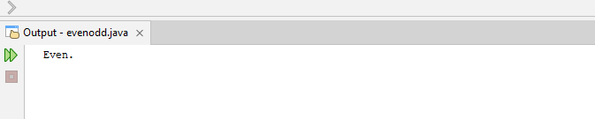

- Write a java program to find the largest number among the three numbers.
Program:
package week4;
public class largestinthree{
public static void main(String[] args){
int a=256, b=43, c=172;
int largest=a>b? (a>c? a:c):(b>c? b:c);
if(largest==a){
System.out.print("a is largest with value: "+a);
}
else if(largest==b){
System.out.print("b is largest with value: "+b);
}
else{
System.out.print("c is largest with value: "+c);
}
}
}
Output:
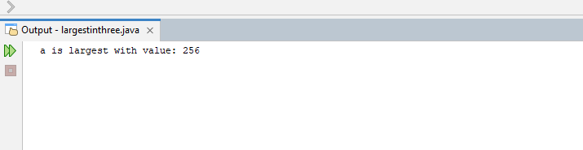
- Write a java program to that takes a number as input and prints its multiplication table upto 10.
Program:
package week4;
import java.util.Scanner;
public class table{
public static void main(String[] args){
Scanner input=new Scanner(System.in);
System.out.print("Enter a positive Integer: ");
int n=input.nextInt();
for(int i=1;i<=10;i++){
System.out.println(n+"x"+i+" = "+(n*i));
}
}
}
Output:
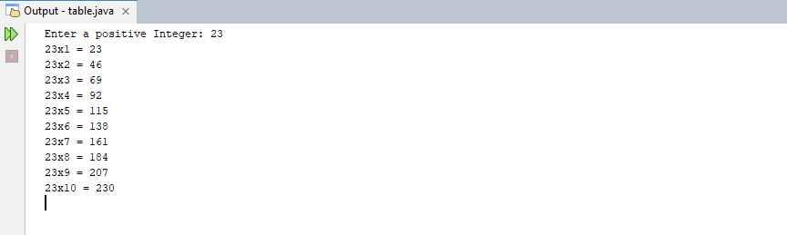

- Write a java program to calculate the sum of the following series:
1+2+3+4+……….+N
Program:
package week4;
import java.util.Scanner;
public class sumofnaturalnums{
public static void main(String[] args){
Scanner input=new Scanner(System.in);

System.out.print("Enter n for the natural numbers series: ");
int n=input.nextInt();
int sum=n*(n+1)/2;
System.out.println("Sum of first "+n+" natural numbers is: "+sum);
}
}
Output:
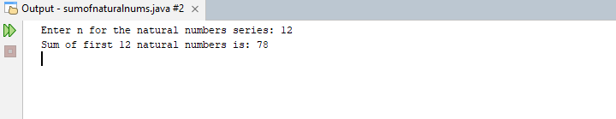

- Write a java program to take a number, divide it by 2 and print the result until the number becomes less than 10.
Program:
package week4;
import java.util.Scanner;
public class divby2{
public static void main(String[] args){
Scanner input=new Scanner(System.in);
System.out.print("Enter an Integer: ");
double num=input.nextDouble();
double res=num/2;
while(res>10){
System.out.println(res);
res/=2;
}
}
}
Output:
